Investigating the Effect of Persistent Inward Currents on Motor Unit Firing Rates and Beta-Band Coherence in a Model of the First Dorsal Interosseous Muscle
Author List: Sageanne Senneff, Lara McManus and Madeleine M. Lowery
Corresponding Author: Dr Madeleine Lowery
School of Electrical and Electronic Engineering,
University College Dublin, Belfield, Dublin 4, Ireland
madeleine.lowery@ucd.ie
Affiliations: S Senneff, L McManus and M. M. Lowery are with the School of Electrical and Electronic Engineering, University College Dublin, Ireland. (e-mail: sageanne.senneff@ucdconnect.ie, madeleine.lowery@ucd.ie).
Link to Published Manuscript, DOI: 10.1109/EMBC.2019.8857534
Details of Funding: Research supported by the European Research Council: ERC-2014-CoG-646923_DBSModel.
© 2019 IEEE. Personal use of this material is permitted. Permission from IEEE must be obtained for all other uses, in any current or future media, including reprinting/republishing this material for advertising or promotional purposes, creating new collective works, for resale or redistribution to servers or lists, or reuse of any copyrighted component of this work in other works.

Abstract
Neuromodulatory drive resulting in the generation of persistent inward currents (PICs) within motoneuron dendrites has been demonstrated to introduce nonlinearities into the motoneuron input-output function for a given motor command. It is less understood, however, as to what role PICs play during voluntary contractions or on the correlation between motoneuron firings arising as a result of common synaptic inputs to the motoneuron pool. To examine this, a biophysical model of the motoneuron pool representing the first dorsal interosseous (FDI) muscle was used to simulate the effects of PICs on motor unit firing patterns and beta-band (15-30 Hz) motor unit coherence at 20, 30, and 40 percent of maximum voluntary contraction (MVC). The contribution of PICs at each MVC was quantified by calculating the difference in the mean firing rate of each motoneuron within the pool and assessing changes in the mean firing rate distribution and motor unit coherence with and without PICs present. The results of the current study demonstrated that increased activation of PICs progressively reduced motor unit coherence, however, changes in coherence were modest when investigating activation levels consistent with experimentally observed mean motor unit firing rates in the FDI muscle during isometric voluntary contraction.

Introduction
Motoneurons within the spinal cord are tasked with integrating thousands of excitatory, inhibitory, and neuromodulatory synaptic inputs and translating them into motor unit action potentials, triggering muscle activation. It is well established that motor unit firing patterns are strongly influenced by neuromodulatory drive, known to induce nonlinearities in synaptic integration by exciting voltage-dependent, dendritic ion channels that produce persistent inward currents (PICs) [1-6]. Recent studies have further hypothesized that the level of neuromodulatory drive sets the excitability of the motoneuron pool across all motor tasks, including highprecision movements, acting as the gain of the motoneuron input-output function [4-6]. Pre-synaptic branched inputs and descending oscillatory inputs, widely believed to be of cortical origin, are two major sources of common input to the motoneuron pool, leading to synchronization between motor unit firing times and increased coherence in the beta-band (15-30 Hz) region [7-9]. Motor unit synchronization has been observed in the first dorsal interosseous (FDI) muscle during sustained voluntary isometric contractions, and has been demonstrated to be greater in the non-dominant versus the dominant hand [10-11]. A recent study showed, for the first time, that betaband motor unit coherence in the FDI muscle increases during fatiguing contractions and post-fatigue, compared to pre-fatigue estimates [9]. Open questions remain as to what effect PICs have on motor unit firing patterns and beta-band motor unit coherence in the presence of common cortical inputs. An experimental study in turtle motoneurons demonstrated that the recruitment of PICs led to reduced motor unit synchronization [12], however it was recently demonstrated that PIC-induced motoneuron depolarization is smaller in larger animals, and therefore may play a smaller role during voluntary contraction in humans [13]. Previous computational studies assessing changes in intramuscular and corticomuscular coherence found contrasting results when looking at the effect of PICs on either branched or oscillatory common inputs, however this was attributed to the difference in methodological approaches when introducing common or correlated synaptic inputs [8,14]. To examine this issue in the present study, a biophysical model of the motoneuron pool was developed for the FDI muscle that was driven by physiological, cortical spike trains generated for a range of force levels. The model was used to investigate the contribution of PICs on motor unit firing rates for increasing levels of maximum voluntary contraction (MVC), as well as changes in the beta-band coherence spectra in response to increased recruitment of PIC-generating ion channels within motoneuron dendrites.

Methods
A biophysical model of the motoneuron pool representing the first dorsal interosseous (FDI) muscle was implemented in NEURON [15] and used to investigate the effect of PICs on beta-band motor unit coherence in response to correlated synaptic inputs for simulated voluntary contractions across a range of force levels. The model was developed from a model developed previously for cat MG and human tibialis anterior motoneurons [6], and adapted for the FDI muscle.
- Model Structure
Each of the 100 motoneurons within the pool were modelled with a five-compartment structure that included a single soma and four dendritic branches. A persistent sodium channel was placed within the soma, as well as four other ionic channels: a transient sodium channel, a delayedrectifier potassium channel, a calcium-dependent potassium channel, and a Hyperpolarization-activated cyclic nucleotidegated (HCN) channel [6]. A slowly inactivating, voltage-dependent persistent calcium channel was placed within each dendrite, and the maximal conductance for each dendrite was varied to ensure unique plateau generation across the four branches [6]. To adapt this model for the FDI, the maximal conductances of the calcium channels were proportionally reduced across the dendrites, uniformly for each motoneuron within the pool, in order to generate plateau potentials resulting in mean motor unit firing rates within the range reported experimentally for the FDI [16-17].
- Synaptic Inputs
A synaptic input was introduced to each motoneuron, at each dendrite, containing three components: an independent excitatory signal, an independent inhibitory signal, and a beta-modulated common signal. The relative contribution of the inhibitory component to the overall independent input (i.e. excitatory + inhibitory) was 25%, while the relative contribution of the common component to the overall synaptic input (i.e. independent + common) was 44%. The ratio of common to independent input was chosen based upon experimental findings in wrist extensor muscles, and adjusted to generate motor unit coherence spectra qualitatively similar to experimental recordings in the FDI [9, 18]. To generate the common signal, a random Gaussian noise signal was band-pass filtered between 12-22 Hz and introduced into an integrate and fire model to generate 2000 weakly beta-modulated cortical spike trains [19]. Each motoneuron received the summation of 100 randomly chosen spike trains, such that 5% of the common input was shared between each motoneuron, combining the effects of presynaptic branching and common oscillatory modulation. A single compartment motoneuron pool model was used to determine the synaptic inputs required to drive the motor unit firing at rates that produce a target force of 20%, 30% and 40% of maximum voluntary contraction (MVC) [20]. The resulting signals were then used as inputs to the biophysical motoneuron pool model described in the current study.
- Data Analysis
To estimate the contribution of PICs on motor unit firing rates at a range of low-force to high-force voluntary contractions, the model was first fit to the available experimental data in the FDI muscle with PICs intact on the dendrites. PICs were then removed from the model at each force level, and the ∆F value was calculated as the changing in firing rate after PIC removal for each motoneuron within the pool. To approximate the effect of PICs on the beta-band motor unit coherence spectra, firing times were extracted for each motoneuron within the pool during simulations performed with increasing dendritic calcium channel densities: 0.0, 1.0, 1.25, 1.50, and 1.75. To control for changes in mean firing rate at each force level in the presence of increasing activation of PICs, each component of the synaptic input was reduced proportionally to maintain the same ratio of excitatory, inhibitory, and common input. A subset of 26 motoneurons, with a cut-off firing frequency of 7 Hz, was chosen at random for coherence analysis at each force level. The subset was split into two groups for coherence analysis using the composite spike train method [10], such that coherence was calculated for all possible combinations of motoneurons within the subset. The same subset was used to calculate coherence at all force levels, for each calcium channel density.

Results
The mean firing rate distribution for the FDI model across force levels is presented in Figures 1A-1C. In order to visualize the contribution of PICs at each MVC, the resulting mean firing rate distribution after removing PICs in the model is presented in shaded gray. The mean firing rate across all recruited motoneurons within the pool (i.e. firing above 7 Hz) dropped from 17.6 Hz to 16.1 Hz, 20.1 Hz to 18.0 Hz, and 22.5 Hz to 19.7 Hz at 20%, 30%, and 40% MVC, respectively, when removing PICs from the model. The mean firing rate range was broader when PICs were included in the model, presenting as 20.0 Hz, 22.8 Hz, and 30.0 Hz at 20%, 30%, and 40% MVC. When PICs were removed from the model, the mean firing rate range dropped to 15.3 Hz, 20.0 Hz, and 22.5 Hz, respectively. The whole pool mean firing rate and firing rate range is presented visually in Figure 2B for each force level, with and without the presence of PICs. In Figure 2A, the change in mean firing rate is presented individually for each motoneuron within the pool, ranging from the lowest to the highest threshold motoneuron. The change in mean firing rate is represented with the value, calculated as the drop in mean firing rate when PICs were removed in the model. The average values across the recruited motoneurons within the pool were calculated as 1.9 Hz, 2.2 Hz, and 3.0 Hz for 77 motoneurons at 20% MVC, 84 motoneurons at 30% MVC, and 87 motoneurons at 40% MVC, respectively. The firing rate range presented at 5.7 Hz, 4.1 Hz, and 8.4 Hz at 20% MVC, 30% MVC, and 40% MVC, with peak values of 6.7 Hz, 5.2 Hz, and 9.1 Hz at each respective force level. Plateau potentials produced by PICs within each dendrite were averaged and presented in Figures 3A-3D for the lowest-threshold motoneuron in the pool, at each force level. The PIC plateau amplitude and rate of onset increased with increasing force, a relationship that was maintained when assessing variations in calcium channel density. When increasing the density of PICs on the dendrites, the sharpest change in plateau amplitude was observed at 20% MVC, while increases were more gradual, with a higher standard deviation, for increasing force levels. The coherence spectra was calculated for each density level and presented in Figures 3E-3H. To assess the change in coherence when PICs were removed from the model (i.e. 0.0 in Figures 3A-3F), whole pool mean firing rate was controlled for by adjusting the amplitude of the total synaptic input, while keeping the ratio between the common and independent components constant. The relative change in the amplitude of the synaptic input was 108.9% for both 20% and 30% MVC and 111.1 % for 40% MVC. The corresponding change in the coherence integral taken across the beta-band frequency spectrum was 119.3%, 115.5%, and 104.8%, respectively, demonstrating that PIC removal had the largest affect on coherence at 20% MVC. To assess whether increased activation of PICs affected the coherence spectra, the density of calcium channels on the dendrites was increased to 1.25, 1.5, and 1.75 times the level used to fit to experimental data in the FDI muscle. The peaks in the coherence spectra over the beta-band region were observed to decrease for increasing density levels, with the largest reduction in the coherence peaks observed at density 1.75. This reduction corresponded to a decrease in the integral of the coherence taken over the beta-band, which was reduced to 29.0%, 45.8%, and 50.1% of its original value at 20%, 30%, and 40% MVC, respectively. To control for mean firing rate at this density, the total synaptic amplitude was reduced to 15.6% of its original value at 20% MVC, 26.7% of its original value at 30% MVC, and 28.9% of its original value at 40% MVC. Changes in the coherence spectra were more modest at the lower density levels, with reductions between 0-20% in the coherence integral for densities 1.25 and 1.5.

Discussion; Motor unit synchronization and increased coherence in the beta-band region has been observed during sustained, voluntary isometric contractions in the FDI muscle of the hand. Increasing evidence has suggested that PICs contribute to motor unit firing patterns across a range of motor tasks, however it is less understood as to what effect they have on branched or oscillatory common cortical inputs responsible for changes in motor unit synchronization. In order to estimate the effects of PICs on motor unit firing times and coherence in the presence of correlated synaptic inputs, a biophysical model of the motoneuron pool was developed for the FDI muscle and simulated at a range of force levels. To the best of our knowledge, there has yet to be an experimental study to quantify the contribution of PICs on motor unit firing rates in the FDI, however studies in the human upper and lower limb have found that PICs can increase motor unit firing rates by 2.9 - 5.4 Hz when comparing two motor units at a time using the paired motor unit technique [5, 21-22]. The peak values observed in the current study were slightly higher than those observed experimentally for the lowest-threshold motoneurons at each force level, while the averaged values across all recruited motor units were a closer fit to the data. This is a reflection of inherent properties in the model built to describe the experimentally observed effect that PICs are recruited more readily in lower-threshold motoneurons [2,6]. When assessing changes in motor unit coherence in the model after fitting to experimental firing rates in the FDI muscle, the results demonstrated that the removal of PICs had a modest effect on coherence, suggesting that PICs may not play a large role during isometric voluntary contraction in the FDI. The largest change in coherence was observed at 20% MVC, potentially due to an interaction between motor unit firing rates and the beta-modulated common input, as the mean firing rate at 20% MVC (17.6 Hz) is similar to the center frequency of the common input (17 Hz). Further simulations were performed to assess the effects of increased activation of PICs on motor unit coherence, represented by increased density of PIC-generating calcium channels on the dendrites. Although the ratio of common to independent input remained constant for increasing densities of PICs, motor unit coherence was observed to decrease in the presence of larger amplitude plateau potentials, particularly at the highest density level. These changes in coherence may be due to a dilution effect of the beta-modulated common input by PICs, as the amplitude of the synaptic input was increasingly reduced at higher density levels. The largest drop in coherence was observed at 20% MVC, as was the largest reduction in synaptic amplitude required to control for mean firing rate, supporting this hypothesis. Decreased coherence may also arise from a shunting effect of the PICs on other ionic conductances in the model, as PIC onset results in depolarization of the membrane potential, limiting the amount of current getting through from other sources [4]. Reduced coherence in the presence of PICs has been observed in a previous computational study [8], however only in the case where beta-modulated oscillatory inputs comprised 90% of the total input signal. A later study assessing changes in corticomuscular coherence reported that removing PICs reduced coherence amplitude [14], however this was attributed to a higher ratio of independent to cortical input when controlling for firing rate. The current study investigates the effects of PICs on motor unit coherence in the presence of physiologically realistic branched and oscillatory common inputs, where the ratio between common and independent cortical inputs are held constant. The results of this study demonstrated that increasing the activation of PICs within motoneuron dendrites progressively reduced motor unit coherence, however only a modest effect was observed at levels consistent with experimental mean firing rates in the FDI muscle during isometric voluntary contraction.

References
[1] C.J. Heckman, R.H. Lee, and R.M. Brownstone, Hyperexcitable dendrites in motoneurons and their neuromodulatory control during motor behavior, Trends in Neurosci., vol. 26(12): 688-695, 2003.
[2] C.J. Heckman, M.A. Gorassini, and D.J. Bennett, Persistent Inward Currents in Motoneuron Dendrites: Implications for Motor Output, Muscle Nerve, vol. 31: 135-156, 2005.
[3] R.K. Powers, S.M. Elbasiouny, W.Z. Rymer et al., Contribution of intrinsic properties and synaptic inputs to motoneuron discharge patterns: a simulation study, J Neurophysiol., vol. 107: 808-823, 2012.
[4] M.D. Johnson and C.J. Heckman, Gain control mechanisms in spinal motoneurons, Front. Neural Circuits, vol. 8(81): 1-7, 2014.
[5] M.D. Johnson, C.K. Thompson, V.M. Tysseling et al., The potential for understanding the synaptic organization of human motor commands via the firing patterns of motoneurons, J. Neurophysiol., vol. 118: 520- 531, 2017.
[6] R.K. Powers and C.J. Heckman, Synaptic control of the shape of the motoneuron pool input-output function, J Neurophysiol., vol. 117: 1171-1184, 2017.
[7] S.F. Farmer, F.D. Bremner, D.M. Halliday et al., The frequency content of common synaptic inputs to motoneurons studied during voluntary isometric contraction in man. J Physiol, vol. 470: 127-155, 1993.
[8] A.M. Taylor and R.M. Enoka, Quantification of the Factors That Influence Discharge Correlation in Model Motor Neurons, J. Neurophysiol., vol. 91: 796-814, 2004.
[9] L. McManus, X. Hu, W.Z. Rymer et al., Muscle fatigue increases beta-band coherence between the firing times of simultaneously active motor units in the first dorsal interosseous muscle, J. Neurophysiol., vol. 115: 2830-2839, 2016.
[10] C.J. De Luca, R.S. LeFever, M.P. McCue et al., Control scheme governing concurrently active human motor units during voluntary contractions, J. Physiol., vol. 329: 129-142, 1982.
[11] G. Kamen, S.S. Greenstein, C.J. De Luca, Lateral dominance and motor unit firing behavior. Brain Res, vol. 576: 165-167, 1992.
[12] G. Svirskis and J. Hounsgaard, Influence of membrane properties on spike synchronization in neurons: theory and experiments, Network: Comp. in Neur. Sys., vol. 14(4): 747-763, 2002.
[13] S. Huh, R. Siripuram, R.H. Lee et al., PICs in motoneurons do not scale with the size of the animal: a possible mechanism for faster speed of muscle contraction in smaller species, J. Neurophysiol, vol. 118(1): 93-102, 2017.
[14] E.R. Williams and S.N. Baker, Circuits Generating Corticomuscular Coherence Investigated Using a Biophysically Based Computational Model, J. Neurophysiol., vol. 101: 31-41, 2009.
[15] M. Hines, A program for simulation of nerve equations with branching geometries, Int. J. Biomed. Comput., vol. 24: 55-68, 1989.
[16] K. Seki and M. Narusawa, Firing rate modulation of human motor units in different muscles during isometric contraction with various forces, Brain Research, vol. 719: 1-7, 1996.
[17] C.J. De Luca and J.C. Kline, Influence of proprioceptive feedback on the firing rate and recruitment of motoneurons, J. Neural Eng., vol. 9: (17pp), 2012.
[18] P.D. Cheney, E.E. Fetz, K. Mewes, Neural mechanisms underlying corticospinal and rubrospinal control of limb movements, Prog. Brain Res., vol. 87: 213-252, 1991.
[19] D.M. Halliday, Generation and characterization of correlated spike trains, Comp. in Biol. and Med., vol. 28: 143-152, 1998.
[20] M.M. Lowery and Z. Erim, A Simulation Study to Examine the Effect of Common Motoneuron Inputs on Correlated Patterns of Motor Unit Discharge, J. Comp. Neurosc., vol. 19: 107-124, 2005.
[21] E. Udina, J. D’Amico, A.J. Bergquist et al., Amphetamine Increases Persistent Inward Currents in Human Motoneurons Estimated From Paired Motor-Unit Activity, J. Neurophysiol., vol. 103: 1295-1303, 2010.
[22] J.M. Wilson, C.K. Thompson, L.C. Miller, and C.J. Heckman, Intrinsic excitability of human motoneurons in biceps brachii versus triceps brachii, J. Neurophysiol, vol. 113: 3692-3699, 2015.

Figures
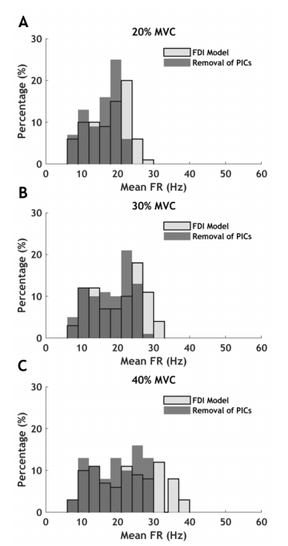
Figure 1: Mean firing rate (Mean FR) distribution at 20% MVC (A), 30% MVC (B), and 40% MVC (C) in the model of the FDI muscle. The effect on the mean firing rate distribution after removing PICs in the model is presented at each force level in gray.
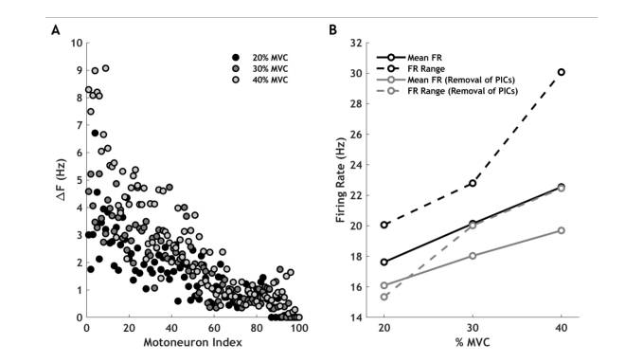
Figure 2: Change in mean firing rate (∆F) for each motoneuron within the pool when PICs are removed from the model at each force level (A). Whole pool mean firing rate and mean firing rate range at each force level both in the FDI model and when PICs are removed (B).

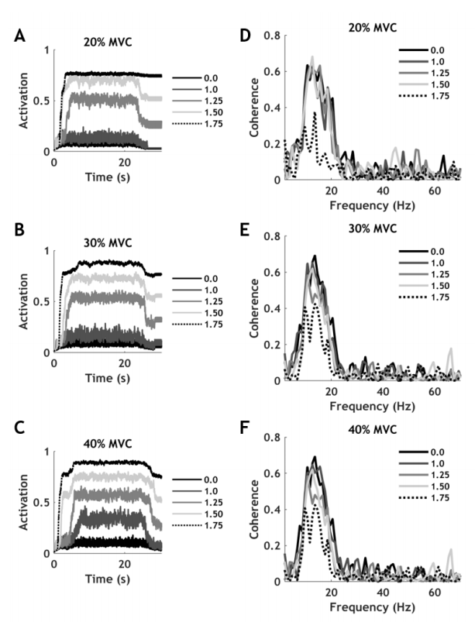
Figure 3: PIC plateau potentials averaged across all dendritic branches in the lowest-threshold motoneuron of the pool at 20% MVC (A), 30% MVC (B), and 40% MVC (C). The corresponding change in the coherence spectra is presented for increasing densities of calcium channels on the dendrites (0, 1.0, 1.25, 1.50, and 1.75) at 20% MVC (D), 30% MVC (E), and 40% MVC (F).

